**Sample requests**

* Add bearer token for the request

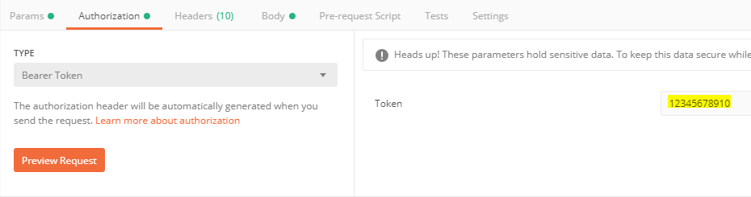

* Host URL – highlighted text needs to be replaced from your site URL (visual studio localhost or IIS hosted)

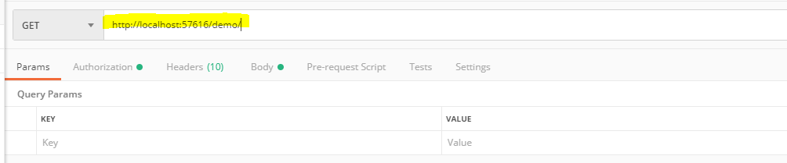

1. Create customer

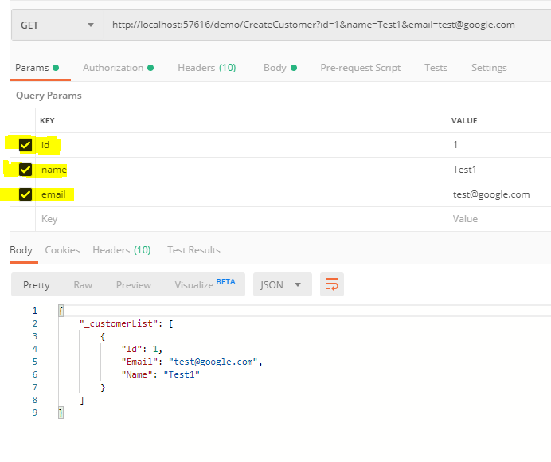

1. Update Customer- *Id value need to be 1*

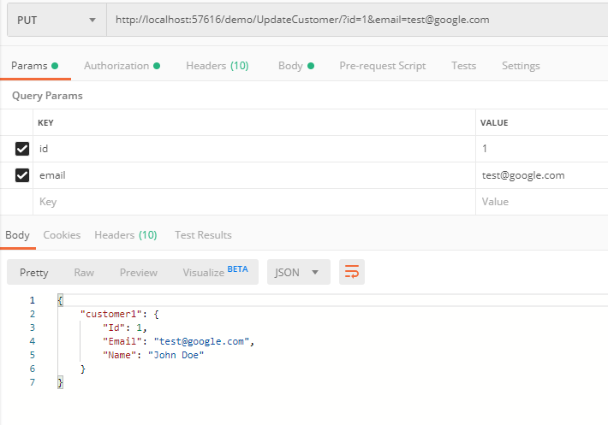

1. Delete Customer – Id value need to 1

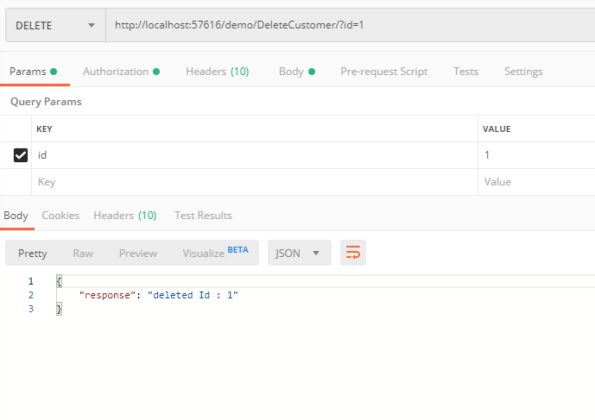

1. File Upload

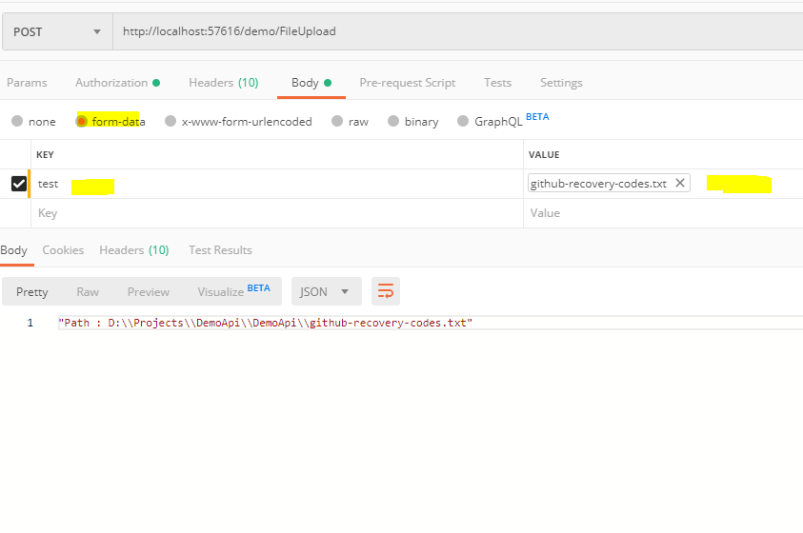

1. File Download

